COS30008 Semester 1, 2024 Dr. Markus Lumpe

# Swinburne University of Technology

School of Science, Computing and Engineering Technologies

# ASSIGNMENT COVER SHEET

**Subject Code:** COS30008

**Subject Title:** Data Structures and Patterns

**Assignment number and title:** 1, Solution Design in C++

**Due date:** Wednesday, March 27, 2024, 23:59

**Lecturer:** Dr. Markus Lumpe

## Your name: Luan Nguyen Your student ID: 103812143

Marker's comments:

|  |  |  |
| --- | --- | --- |
| Problem | Marks | Obtained |
| 1 | 26 |  |
| 2 | 98 |  |
| 3 | 32 |  |
| Total | 156 |  |

## Extension certification:

This assignment has been given an extension and is now due on

Signature of Convener:

Problem 1- toString() function implementation

Figure 1. Problem1 - toString()

Reformat the value to round to 4 decimal and convert to string 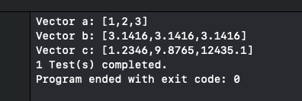

Figure 2. Test 1 result

Problem 2: Matrices

1. Multiply 2 Matrices

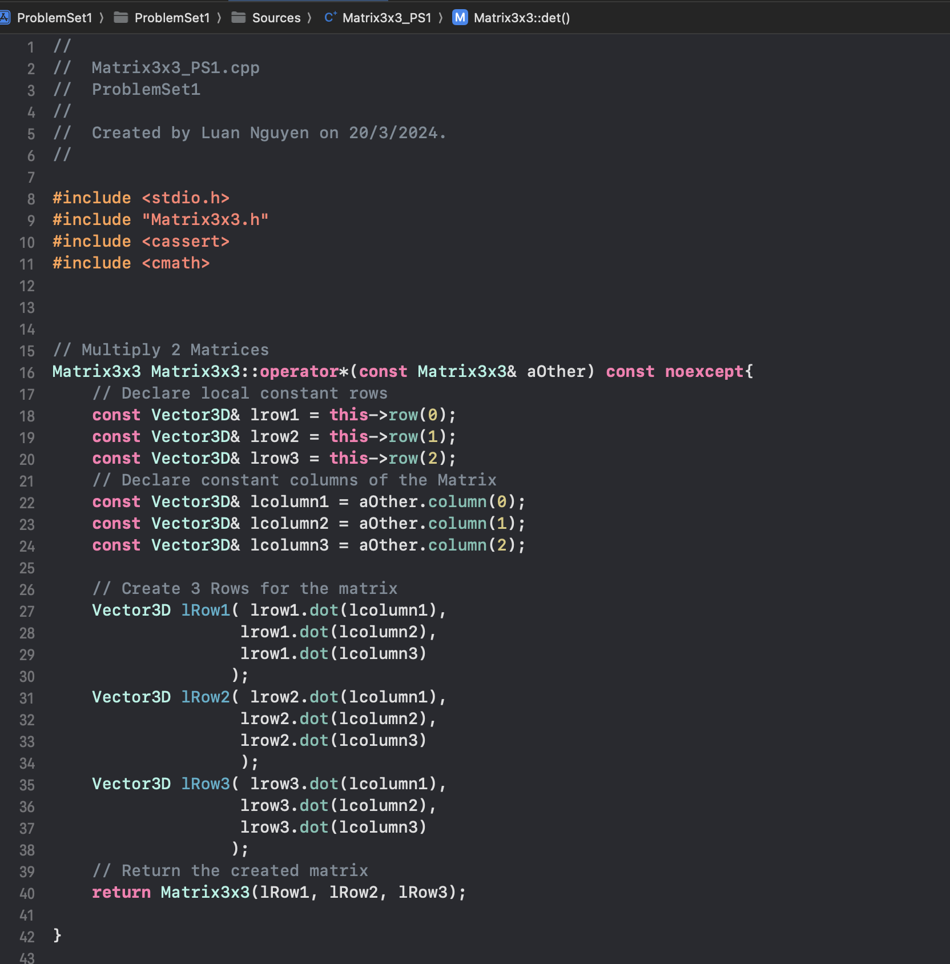

Figure 3. Multiply Matrices

Declaring the local reference to maximize the memory using while not calling row() and column() too many times, dot() the column() of this matrix to the row() of the other to get the entry of the new Matrix and return the how 3x3Matrix

1. Determine of a Matrix

By apply this fomular, we can calculate the determine of the matrix using row(column_Index)[row_Index] to access the value

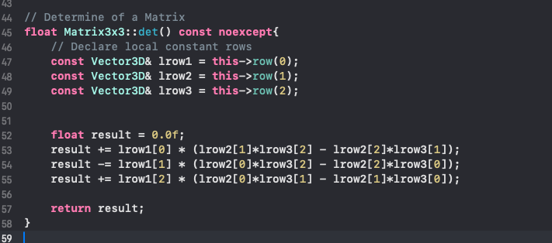

Figure 4. Determine of a Matrix

1. Transpose the Matrix

Convert the row to column of the Matrix to transpose it in which the n x m **M** to m x n **M**

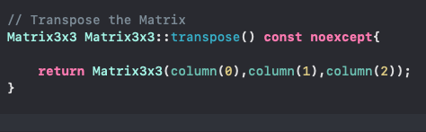

Figure 5. Transpose

1. Invertibility

If the det() of the matrix is not 0 so it is invertible

Figure 6. Invertibility

1. Inverse the matrix

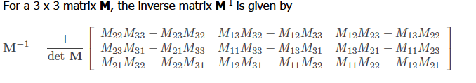

Similarly to det() access the matrix using row() and then multipy it with 1/det()

Figure 7. Inverse()

1. Apply toString() to the matrix

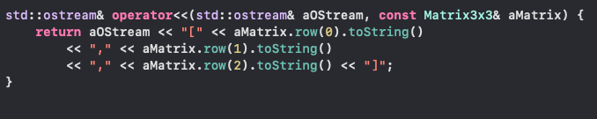

Figure 8. toString()

Problem 3: Polygon

1. Get the area

By using given the trapezoid formula for polygon implement the function to calculate the area of the polygon

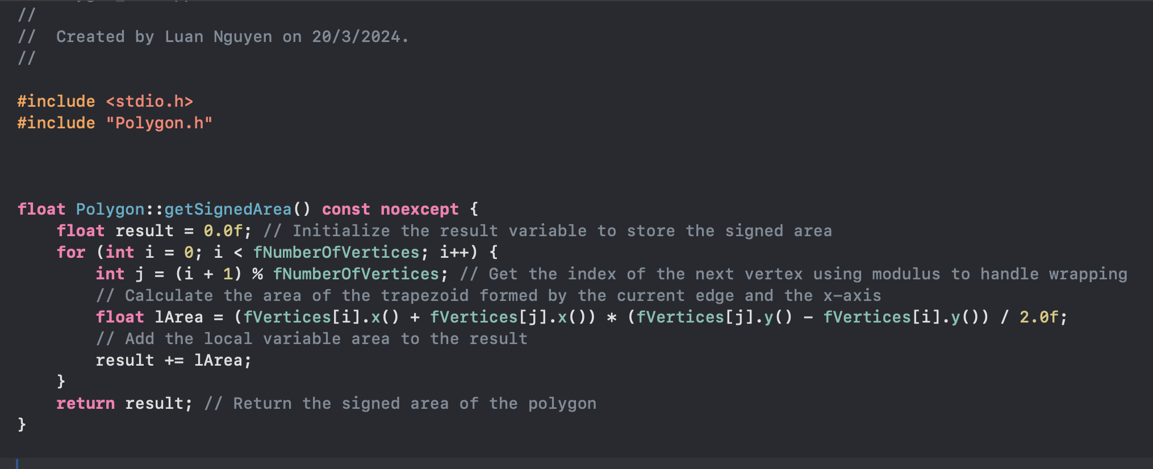

Figure 9. Calculate the area

1. Transform the Polygon

By applying a 3x3 transformation to each vertex

Figure 10. Transform the Polygon